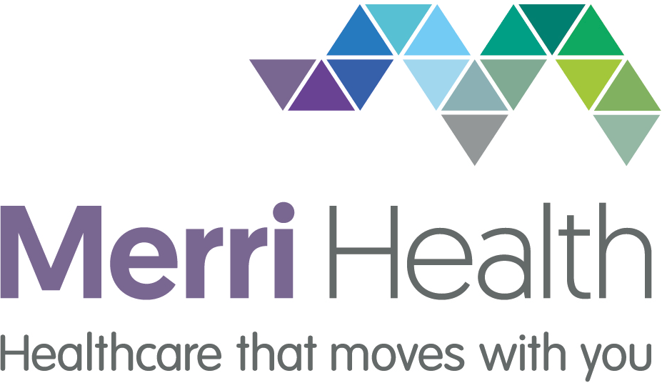
11 Glenlyon Road, Brunswick VIC 3056
Tel. (03) 9387 6711 Fax. (03) 9387 5417
www.merrihealth.org.au
ABN 24550946840

Title of Form:
Changing Lives Award nomination

Thank you for taking the time to nominate a Merri Health employee for a Changing Lives Award.

Date of submission

Nomination information
Name of staff
Service provided
What office do they work in?
Does your nominee know they are being nominated for this award? Yes No

I am a:
Please tick one Client Partner, family member or friend of a client

Reason for nomination
What has this person done to impress you?
What impact has this person had on your life?
How have they helped your health or wellbeing?
If you are not a client; how have they helped your family, friend or loved one's health or wellbeing? (Only complete this section if you are a family, friend or loved one of someone receiving a service)

Can we contact you to find our more information?
Yes No

If yes, please provide your name, phone number and email address.

Nominations are to be sent to hr@merrihealth.org.au or dropped off at one of our sites.

Office use only
Date reviewed by the Board Community Eng. subcommittee Approved for award

Yes No

